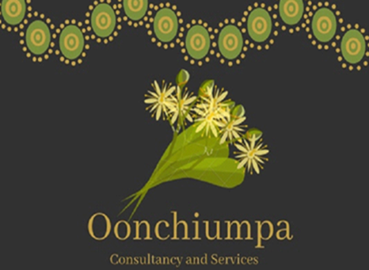

Oonchiumpa Consultancy and Services

Level 1, Minerals House 58 Hartley Street

Alice Springs NT 0870

Phone: 0474 702 523

Email: [admin@oonchiumpaconsultancy.com.au](mailto:admin@oonchiumpaconsultancy.com.au)

***“Two Cultures, One World, Working Together”***

**Good News Story Oonchiumpa**

The girls enjoyed an afternoon out with Katrina watching the semi-final for under 16 cruiser boys.

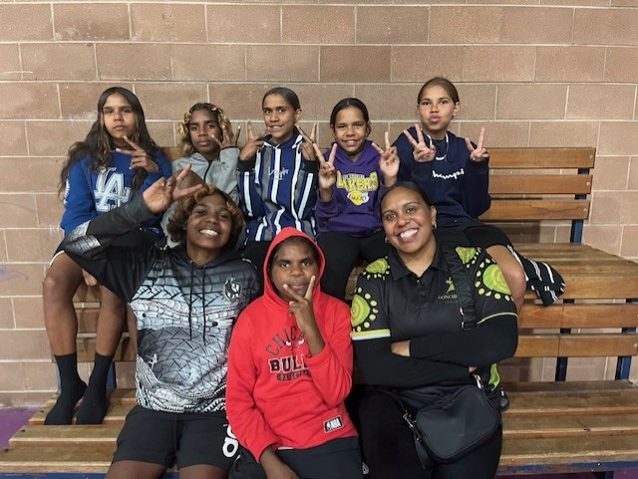The girls have now expressed their interest to play basketball next season. This was an opportunity for the girls to try something new and be apart of the local competition and the basketball community. This was the first time that some of the girls have ever been inside the basketball stadium, Katrina had 5 girls who are on our Oonchiumpa team/list and 1 who is the sister of one of the girls.

